PySpark Documentation

1. Introduction to PySpark

What is PySpark?
PySpark is the Python API for Apache Spark. It allows you to process large-scale data efficiently using distributed computing. PySpark is widely used in data engineering, data analytics, and machine learning workflows.

Why PySpark?
- Handles big data (TBs to PBs)
- Faster than traditional Python due to in-memory processing
- Supports distributed computing
- Integrates with SQL, ML, Streaming, and Graph processing

Where PySpark is Used
- ETL pipelines
- Data engineering workflows
- Real-time data processing
- Machine learning at scale

2. Apache Spark Architecture

High-Level Architecture
Spark follows a master–worker architecture.

Key Components

1. Driver
- Brain of the Spark application
- Converts code into execution plans
- Schedules tasks
- Maintains SparkContext

2. Cluster Manager
- Allocates resources
- Examples: Standalone, YARN, Kubernetes

3. Worker Node
- Executes tasks assigned by the driver

4. Executor
- Runs tasks
- Stores data in memory
- Reports results back to the driver

3. PySpark Setup (Databricks Community Edition)

Why Databricks for PySpark?
Databricks Community Edition provides a free, cloud-based Spark environment where Spark is already configured. You don’t need to install Java, Spark, or Python locally.

Advantages
- Zero installation
- Pre-configured Spark cluster
- Integrated notebooks
- Built-in Spark UI

Databricks Community Edition Setup
- Go to Databricks Community Edition website
- Sign up using email or GitHub
- Login → Workspace opens automatically

Create a Cluster
- Navigate to Compute
- Create a new cluster
- Choose default runtime
- Click Create Cluster
Note: In Community Edition, cluster auto-starts when notebook runs.

4. SparkSession (Databricks)

SparkSession in Databricks
In Databricks, SparkSession is created automatically and available as spark.
You do NOT need to create it manually.

Example
spark

If Needed (Manual – Rare Case)
from pyspark.sql import SparkSession
spark = SparkSession.builder.getOrCreate()

5. Core Concepts

RDD (Resilient Distributed Dataset)

What is RDD?
RDD is the fundamental data structure of Spark.

Characteristics
- Immutable
- Distributed
- Fault-tolerant

Creating RDD
data = [1, 2, 3, 4]
rdd = spark.sparkContext.parallelize(data)

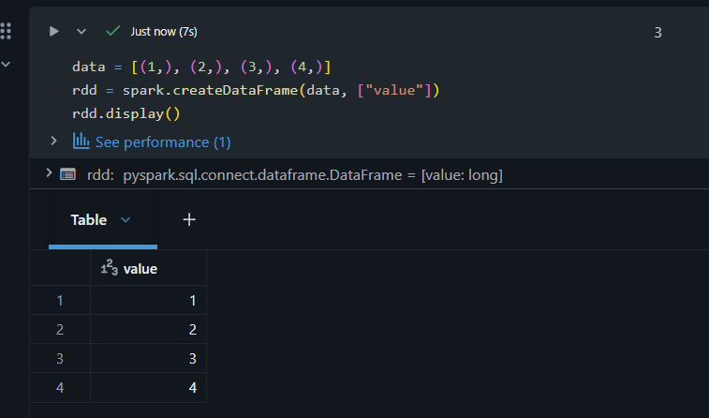

Common RDD Operations
- map()
- filter()
- reduce()
- collect()

6. DataFrame API

What is DataFrame?
A DataFrame is a distributed collection of data organized into named columns (similar to a SQL table).

Creating DataFrame
data = [(1, "A"), (2, "B")]
df = spark.createDataFrame(data, ["id", "name"])

Common DataFrame Operations
- select()
- filter()
- withColumn()
- groupBy()
- agg()

7. Reading and Writing Data (Databricks)

Databricks File System (DBFS)
Databricks uses DBFS to store files.
Common Paths:
- /FileStore/ → Upload files manually
- dbfs:/FileStore/ → Spark readable path

Upload Data
- Go to Data → Add Data → Upload File

Read CSV from DBFS
df = spark.read.option("header", True).csv("dbfs:/FileStore/data.csv")

Write Data
df.write.mode("overwrite").parquet("dbfs:/FileStore/output")

8. Transformations vs Actions

Transformations
- Lazy evaluation
- Creates a new DataFrame/RDD
Examples:
- select()
- filter()
- map()

Actions
- Triggers execution
Examples:
- show()
- collect()
- count()

9. PySpark SQL

Register Temp View
df.createOrReplaceTempView("table")

Run SQL Query
spark.sql("SELECT * FROM table WHERE id > 1")

10. Functions and Expressions

Common Functions
- col()
- when()
- count()
- sum()
Example:
from pyspark.sql.functions import col, when

df.withColumn("flag", when(col("age") > 18, "Adult").otherwise("Minor"))

11. Handling Missing Values
Before that we have to segregate the Numerical Columns and Categorical Columns then ,
First, separate numerical and categorical columns.

For numerical columns with missing values, impute them with the column's mean.

df.selectExpr("avg(Item_Weight)").display()
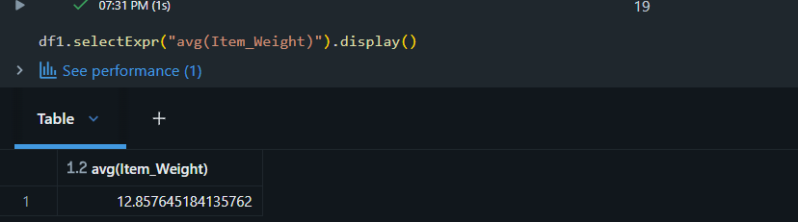

Impute missing categorical values with the mode (most frequent element).

The mode of "Outlet_Size" is found using:

df.groupBy("Outlet_Size").count().orderBy("count", ascending=False).display()
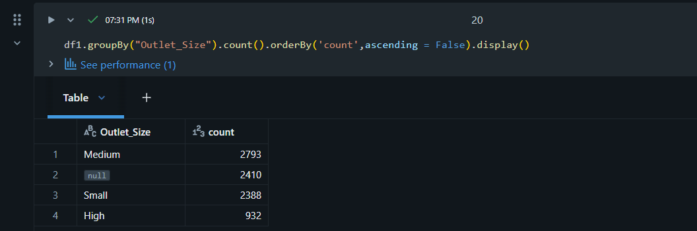

Example: Filling Missing Values (Manual)
To manually fill missing values in a PySpark DataFrame without calculating mean/mode first, you can use the fillna() method directly.

Fill Missing Valuesdf = df.fillna({"Item_Weight": 12.857, "Outlet_Size": "Medium"})

Explanation:

- This command replaces any null values in the Item_Weight column with the numerical value 12.857 (a commonly computed mean/median).
- It replaces any null values in the Outlet_Size column with the string value "Medium" (a commonly computed mode).

12. End-to-End Data Cleaning Use Case (Databricks Community Edition)

Use Case Overview
This documentation demonstrates an end-to-end PySpark data cleaning workflow using a real-world dataset executed on Databricks Community Edition.
Dataset: BigMart Sales Dataset
Platform: Databricks Community Edition
Objective:
- Identify missing values
- Handle missing values
- Clean messy categorical columns

Step 1: Upload Dataset to Databricks
- Go to Data → Add Data → Upload File
- Upload BigMart Sales.csv
- Note the DBFS path (example):
dbfs:/FileStore/BigMart Sales.csv

Step 2: Read Dataset Using PySpark
df = spark.read.option("header", True).option("inferSchema", True) \
.csv("dbfs:/FileStore/BigMart Sales.csv")

Step 3: Understand the Data
df.printSchema()
df.show(5)
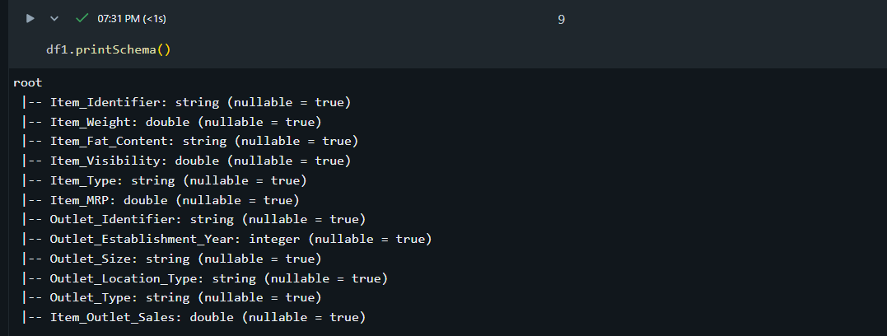

Purpose:
- Understand column data types
- Identify numerical and categorical columns

Step 4: Identify Missing Values
from pyspark.sql.functions import col, count, when

missing_df = df.select([
count(when(col(c).isNull(), c)).alias(c)
for c in df.columns
])

missing_df.show()
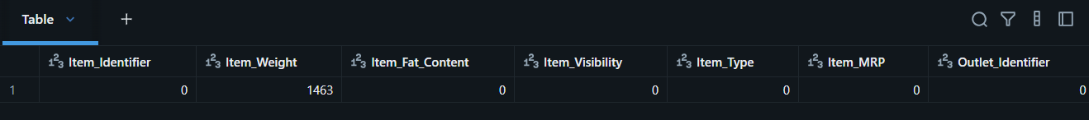
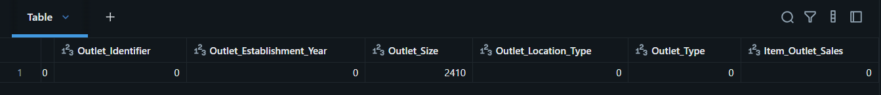

Explanation:
- when() checks condition for null values
- count() counts nulls column-wise
- Helps identify columns requiring cleaning

Step 5: Handling Missing Values (Numerical Columns)

Strategy Used
- Replace missing values with mean / median
from pyspark.sql.functions import mean

mean_value = df.select(mean("Item_Weight")).collect()[0][0]
df = df.fillna({"Item_Weight": mean_value})
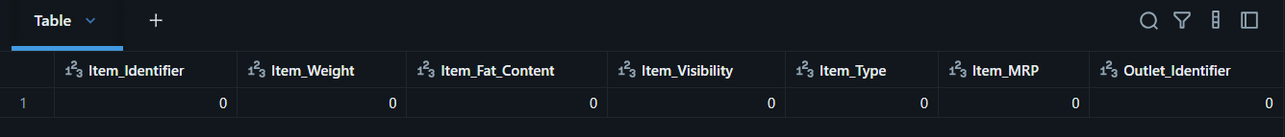


Step 6: Handling Missing Values (Categorical Columns)

Strategy Used
- Replace nulls with most frequent value (mode)
mode_value = df.groupBy("Outlet_Size") \
.count() \
.orderBy(col("count").desc()) \
.first()[0]

df = df.fillna({"Outlet_Size": mode_value})

Step 7: Cleaning Messy Categorical Values
Problem:
- Inconsistent values like:
  - Low Fat, LF, low fat
  - reg, Regular

from pyspark.sql.functions import lower, when

df = df.withColumn(
"Item_Fat_Content",
when(lower(col("Item_Fat_Content")).isin("lf", "low fat"), "Low Fat")
.when(lower(col("Item_Fat_Content")).isin("reg", "regular"), "Regular")
.otherwise(col("Item_Fat_Content"))
)

Step 8: Validate Cleaned Data
df.groupBy("Item_Fat_Content").count().show()
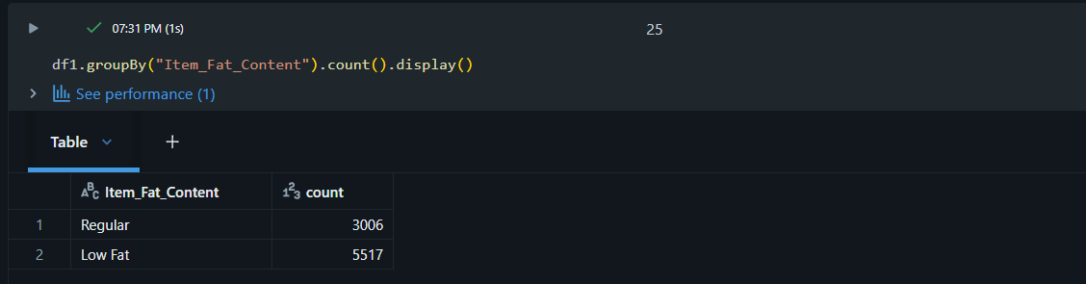

Purpose:
- Ensure categorical values are standardized

Step 9: Final Data Check
df.select([
count(when(col(c).isNull(), c)).alias(c)
for c in df.columns
]).show()

Expected Outcome:
- No missing values
- Clean and standardized categorical columns

Step 10: Conclusion
This notebook demonstrates how PySpark on Databricks Community Edition can be used to:
- Handle missing data efficiently
- Clean real-world messy categorical values
- Prepare datasets for analytics and machine learning

13. Conclusion
PySpark is a powerful tool for big data processing. Understanding its architecture, core concepts, and APIs is essential for building scalable data pipelines.

14. Next Steps (Databricks Learning Path)
- Delta Lake basics
- Databricks SQL
- Notebook workflows
- Job scheduling (Databricks)
- Performance tuning

